**REMOTE REPORT EXECUTION**

**(Sakai Report Tool)**

TECHNICAL MANUAL

By: Sergio Muriel

Date: April, 2015

MAHARISHI UNIVERSITY OF MANAGEMENT

COMPUTER SCIENCE DEPARTMENT

2015

**Description**

Remote Report is an application that allows faculty to obtain reports of their courses in their email addresses based on the information that is already in Sakai system. In this application many technologies work together, namely:

* JSP: The homepage of this tool.
* RESTful Web Services: Current user logged in to Sakai, Sakai Membership and Sakai Site (to get the title of the course).
* SOAP Web Service: This is to retrieve the whole course list.
* XMLRPC: This is necessary to do RPC from Sakai server to the Windows server.
* Batch file: Calls the Excel Macro, compresses generated PDF files and the sends the email.
* Excel Macro: Is the macro that generates the report.
* ODBC: What the Excel macro uses ODBC to connect to Sakai database.

**Use Case 001: Get Sakai Report**

*Success scenario*

1. The user logs in to Sakai.
2. The user goes to the Remote Report Application (Sakai Report) page.
3. The system shows a list of courses according to the role that the user has for each of them. The system also shows the email address of the user (since it was already stored on Sakai).
4. The user selects a set of courses from the Course/Period list.
5. The user types his email address in the email address textbox or does not type anything but uses the email address retrieved by the system.
6. The user clicks the Submit button.
7. The system shows a message telling the user that he will receive the reports of the courses in his email address.

*Exceptions*

3.a The user is not logged in to Sakai, so the application asks the user to log in to Sakai and reload the page.

6.a The system asks the user to select at least one course.

6.b The system asks the user to enter a valid email address.

*Alternate Flow*

4.a The user types a string in the Filter text box and clicks the Filter button.

4.b The system shows a smaller list of courses in the Course/Period list box or tells the user that the typed string does not match any option.

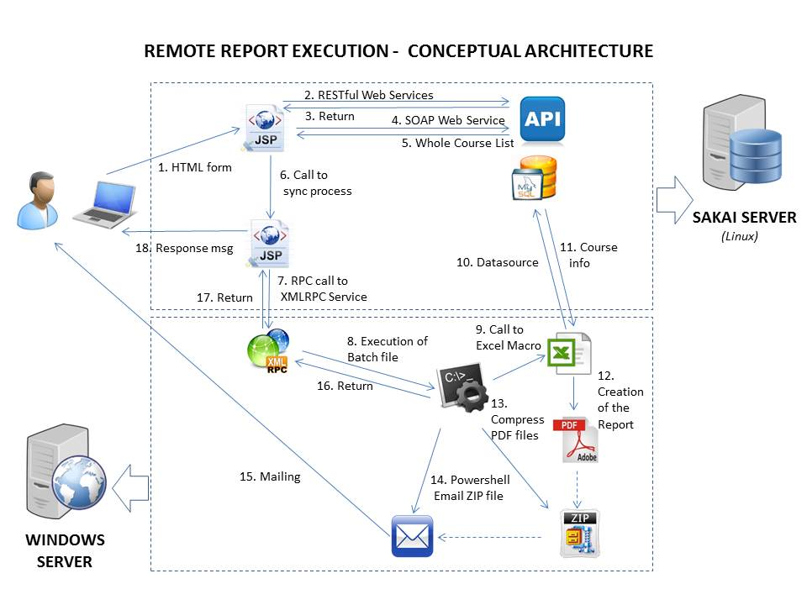

**Step 1**

The user requests access to the application using a browser.

**Step 2**

Three Sakai RESTful web services are called from the page:

1. User/current: This is to check if the user is logged in to Sakai. If so, the email address is taken.
2. Membership: This is to check the courses for which the user belongs to.
3. Site: This is to retrieve the name of the course, since the web service above only gives the site ID.

**Step 3**

The application let the user go ahead or it tells the user to log in to Sakai or it lets the user know that is not allowed to continue if the user is not faculty.

**Step 4**

The application requests the list of courses via the RemoteReportCourses secure web service.

**Step 5**

Sakai returns the course list and the application shows this list in a multiple select box and also shows an email text box and a submit button.

**Step 6**

The user enters the information specified in **Use Case 001: Get Sakai Report** and clicks the submit button. The application starts a synchronized process.

**Step 7**

The application does an RPC call to an XMLRPC service that is located in a Windows server.

**Step 8**

The XMLRPC service executes a batch process located in the same server it is running.

**Step 9**

The batch process calls the Excel Macro as many times as courses selected by the user.

**Step 10**

The Excel Macro connects with Sakai database via data source.

**Step 11**

Sakai returns the information requested for every course.

**Step 12**

The Excel Macro creates a PDF report for every course.

**Step 13**

The batch process compresses every *.PDF file created for the current request.

**Step 14**

The batch process runs Powershell and emails the ZIP file to the email address previously typed by the user.

**Step 15**

The email reaches the inbox of the user at some time.

**Step 16**

The batch process finalizes and returns to the XMLRPC service.

**Step 17**

The XMLRPC method of the service finalizes and gives the control to the application.

**Step 18**

The application shows a message telling the user that he will receive the reports of the courses in his email address.